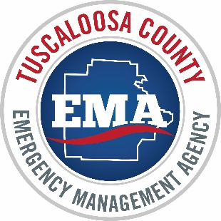_____________________________________________________________________________________
TUSCALOOSA COUNTY
EMERGENCY MANAGEMENT AGENCY
7400 Richard M. Pierce Parkway, Northport, AL 35473
PH: 205-349-0150 ema@tuscco.com www.TuscaloosaCountyEMA.org

Safer Places Application Checklist

- Three (3) People identified to be 24/7 points of contact for your facility
- A signed copy of the Tuscaloosa County Safer Places Memorandum of Understanding (MOU)
- At least three exterior photographs of your facility
- Photographs of your parking lot and any specifically marked parking areas for persons with disabilities
- At least three (3) photographs of the room(s) or area(s) that you would like to utilize as the Safer Place
- Your facility meets all applicable building code in effect at the time of construction
- The selected facilities must have a clearly stated notice that any individual who uses a Safer Place facility does so at their own risk with full knowledge and appreciation of the associated risks
- Signage should be on display identifying a Safer Place location.
- A facility floor plan that clearly indicates the following:
- Which part(s) of your facility that you would like to utilize as the Safer Place
- What floor of your building that these room(s) / area(s) are on
- Where you would like people to enter and exit your facility
*Please note this does not have to be a set of blue prints of your facility*
- Your facilities severe weather plan (if your facility has one in place)

