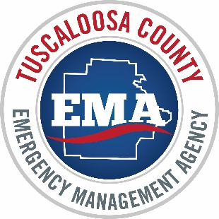_____________________________________________________________________________________
TUSCALOOSA COUNTY
EMERGENCY MANAGEMENT AGENCY
7400 Richard M. Pierce Parkway, Northport, AL 35473
PH: 205-349-0150 ema@tuscco.com www.TuscaloosaCountyEMA.org

Safer Places General Facility Guidelines

- The facility should provide improved protection from the elements
- The condition of the facility should be suitable for occupation and nothing in the facility should pose a direct threat to the health and safety of those seeking refuge
- There must be a secondary exit from the facility, to provide for safe exit in the event of fire or other emergency
- There must be smoke detectors that comply with applicable building codes
- There should be sufficient sanitary facilities that are in proper working condition, are private, and are adequate for personal cleanliness and the disposal of human waste. These facilities should be ADA-accessible whenever possible

